**Chartering Report**

We used the recruiting tool of the subject´s forum. The manager posted an announcement to recruit a new team of members to work for the project. The developers requested applying and the manager approved them, after checking their project objective were like the manager´s, by adding them to the group.

Nieto Córdoba, Pablo / [pabniecor@alum.us.es](mailto:pabniecor@alum.us.es) / 

Román Jiménez, Darío / [darromjim@alum.us.es](mailto:darromjim@alum.us.es) / 

Granado Oliva, Samuel / [samgraoli@alum.us.es](mailto:samgraoli@alum.us.es) / 

Jiménez de la Fuente, Antonio Luis / [antjimde@alum.us.es](mailto:antjimde@alum.us.es) / 

Vela Molina, Alejandro / [alevelmol@alum.us.es](mailto:alevelmol@alum.us.es) / 

Our shared objective is to successfully pass this subject with a C grade.

We consider performing well if this expression is true: (Expected goal – Achieved goal) <= 0. The expected goal will be all the mandatory requirements and the achieved goal the requirements we have done.

Workgroup members who perform well will be rewarded with a C grade.

Workgroup members who perform poorly will be admonished with an F grade.

A workgroup member may be dismissed from the team if they fail to complete all the issues assigned to him/her before the deadline.

19/02/2025

Signed by: Nieto Córdoba, Pablo

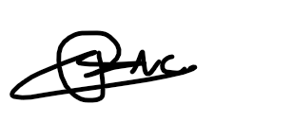

Román Jiménez, Darío

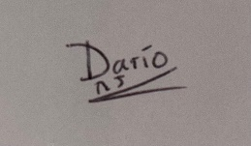

Granado Oliva, Samuel



Jiménez de la Fuente, Antonio Luis



Vela Molina, Alejandro

